List of Experiments

- (a) Write a C program to add two numbers

  - Write a C program to add three numbers

- (a) Write a C program to find area of circle

  - Write a C program to calculate simple interest

- Write a C program to print a block F using hash (#), where the F has a height of six characters and width of five and four characters

- Write a C program that accepts two item’s weight (floating points' values) and number of purchase (floating points' values) and calculate the average value of the items

- (a) Write a C program to swap two variables using a third variable

  - Write a C program to swap two variables without using a third variable

- (a) Write a C program to convert a given integer (in seconds) to hours, minutes, and seconds.

  - Write a C program to convert specified days into years, weeks, and days.
  - Write a C program to check whether a number is even or odd.

- Write a C program to check whether a given year is Leap year or not

- (a) Write a C program to check whether a triangle is Equilateral, scalene, or isosceles

  - Write a C program to check whether a triangle is right angles, obtuse, acute triangle

- Write a C program to covert temperature from Fahrenheit to Celsius and Celsius to Fahrenheit (User must provide the choice of type of temperature)

- (a) Write a C program to check whether a character is an alphabet, digit

  - Write a C program a program to check whether an alphabet is a vowel or consonant

- (a) Write a C program to find smallest of two numbers

  - Write a C program to find largest of three numbers

- Write a program in C to implement Simple Calculator.

- WAP to calculate the root of a Quadratic Equation

- WAP to to accept a coordinate point in a XY coordinate system and determine in which quadrant the coordinate point lies.
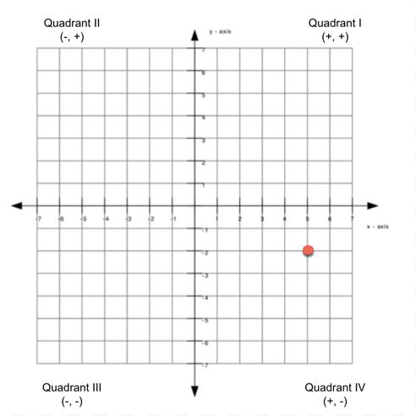

- Write a program to find gross salary of employee if DA is 40% of basic Salary and HRA is 20% of basic salary. Basic salary will be entered as input by keyboard.

- Write a program in C to calculate and print the Electricity bill of a given customer. The customer id and unit consumed by the user should be taken from the keyboard and display the total amount to pay to the customer.

upto 199------------1.20 200-500-------------1.80 Above 500----------2.00

If bill exceeds Rs. 400 then a surcharge of 15% will be charged and the minimum bill should be of Rs. 100/-

- A library charges a fine for every book returned late. For first 5 days the fine is 50 paisa, for 6-10 days, fine is one rupee and above 10 days, fine is 5 rupees. If you return the book after 30 days your membership will be cancelled. Write a program to accept the number of days the member is late to return the book and display the fine or appropriate message.

- Write a program to find the factorial of any number.

- Write a program to print Fibonacci sequence

0 1 1 2 3 5 8 13…… N terms and prints the sum of sequence.

- Write a program in C to accept an integer numbers and find sum of digits.

- Write a program in C to accept an integer numbers and find reverse of this number and check this number for palindrome

- Write a program in C to accept an integer numbers and to check a number is Armstrong or not

- Write a program in C to accept an integer numbers and to check a number is Perfect or not

- Write a program to find the sum of following series:

S = 2+4+6+8+……………N terms.

- Write a program to check a number whether it is prime number or not.

- Write a program to find the sum of following series:

1 – 1/2 + 1/3 – 1/4 + 1/5 - …… up to n terms.

- Write a program to find the sum of following series:

1! + 2! + 3! + 4! + ….. + n!

- Write a program to find the sum of following series: S = -1³ + 3³ - 5³ + 7³ – 9³ + 11³ - ……..N terms.

- Write a program to find the sum of following series:

S = 1/1! + 2/2! + 3/3! + ………….. 7 terms.

- Write a program to convert binary number to decimal number.

- Write a program to find the sum of following series: S = 1⁴ + 3⁴ + 5⁴ + 7⁴ + …………….. 100 terms

- Write a program in C to print the following pattern:

* | * | *
* | * | *
* | * | *
33. Write a program in C to print the following pattern:

1 | 2 | 3
1 | 2 | 3
1 | 2 | 3
34. Write a program in C to print the following pattern:
1 | 1 | 1
2 | 2 | 2
3 | 3 | 3
35. Write a program in C to print the following pattern:

3 | 2 | 1
3 | 2 | 1
3 | 2 | 1
36. Write a program in C to print the following pattern:

3 | 3 | 3
2 | 2 | 2
1 | 1 | 1

37. Write a program in C to print the following pattern:

*
* *
* * *

38. Write a program in C to print the following pattern:

1
1 | 2
1 | 2 | 3
39. Write a program in C to print the following pattern:
1
2 | 2
3 | 3 | 3
40. Write a program in C to print the following pattern:
3
3 | 2
3 | 2 | 1
41. Write a program in C to print the following pattern:
3
2 | 2
1 | 1 | 1
42. Write a program in C to print the following pattern:
 |  |  | *
 |  | * | * | *
 | * | * | * | * | *
* | * | * | * | * | * | *

43. Write a program in C to print the following pattern:

 |  |  | 1
 |  | 1 | 2 | 1
 | 1 | 2 | 3 | 2 | 1
1 | 2 | 3 | 4 | 3 | 2 | 1

44. Write a program in C to print the following pattern:

 |  |  |  | 5
 |  |  | 5 | 4 | 5
 |  | 5 | 4 | 3 | 4 | 5
 | 5 | 4 | 3 | 2 | 3 | 4 | 5
5 | 4 | 3 | 2 | 1 | 2 | 3 | 2 | 1

45. Write a program in C to print the following pattern:

1
0 | 1
1 | 0 | 1
0 | 1 | 0 | 1
1 | 0 | 1 | 0 | 1

- Write a program to print all prime numbers <= a given number.

- Write a program to convert Decimal no to Binary No.

- Write a program to find product, sum, average, max and min from a list of n numbers.

- Write a program in C to display the index of smallest and largest element in 10 integers

- Write a program in C to display the index of smallest and largest element in 3 X 4 matrix of integers.

- Write a program in C that accepts N*N matrix as input and print transpose of this matrix

- Write a program to accept two matrices of some order. (Order must be given by user) find out the sum of these matrices and print the sum of matrices.

- Write a program to find out the product/Multiplication of two matrices and print the product matrix. (order of matrices must be given by user)

- Write a program to accept two matrices of some order. (Order must be given by user) find out the subtraction of these matrices and print the sum of matrices.

Link for Submission of Lab records on regular basis

https://forms.office.com/Pages/ResponsePage.aspx?id=dqBGjZPQbUGle4aSzeE7-ICzcAAXanRAmzdEwRo89QNUNkRWSFRNR0YyWEFVWTBLNEFNQ0xLWDlUSS4u

